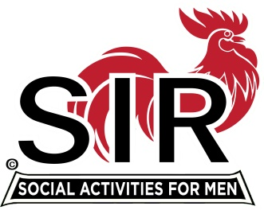
Las Trampas Branch 116
BEC Meeting Agenda
November 15, 2021, 8:30 AM via Zoom
[Zoom login at the bottom of the agenda]
The Mission of SIR is to enhance the lives of our members through fun activities, events and luncheons – while making friends for life.

8:30 am Call to order; Secretary confirm a quorum
8:35 Secretary –Paul Ramacciotti – Approval of October 18, 2021 BEC meeting minutes
8:40 Treasurer –/Alan Fitzgerald – Report
8:45 Standing Reports
- Membership – Phil Goff
- RAMP Department Head Reports:
- Recruitment
- Activity Coordinator
- Member relations
- Publicity
- Covid Compliance [Kevin Donahue]

9:00 Big SIR Report – Sam Beret

- Nov 15 monthly meeting agenda

9:10 Little SIR Report - Fred Wachowicz
1. Speaker
2. Birthday Boys
3. Diversity Team Report

9:20 Old Business

9:25 New Business
- BEC meeting on December 20th?

9:45 Adjourn; Next BEC Meeting December 20, 2021 or January 17, 2022

Zoom Link:

https://us02web.zoom.us/j/89269854543
Meeting ID: 892 6985 4543
Passcode: 826904

Dial-in: (669) 900-9128

